

NAME: _____________________________________________________________________________________

Business Name:_____________________________________________________________________

ADDRESS: ____________________________________________________________________________________

PHONE NUMBER: ________________________ EMAIL: _______________________________________________________

**______Ham & Cheese(on Hawaiian Bread Bun) _____Chicken Salad** on Croissant

**________Vegetarian Wrap**

**Total # Lunches:_________**

X **$10**/Lunch= $_________

**Mail-in Orders**: Include **ORDER FORM AND CHECK(**made out to GSC),

**Mail to** : GSC, 119 N. A Street, Lenoir City, TN 37771

**Online Orders: Pay** by **CREDIT CARD ONLINE at:** [www.goodsamloudoncounty.org](http://www.goodsamloudoncounty.org). (**click: DONATE / complete credit card Transaction,** **In Memo line designate sandwich, number of each and pick-up location)**

The Good Samaritan Center of Loudon County 119 North A Street, Lenoir City, TN

865-986-1777 [www.goodsamloudoncounty.org](http://www.goodsamloudoncounty.org)

Good Samaritan Center of Loudon County

**Picnic Box Lunch Sale**



**September 11, 2025**

**Menu Choice of Sandwich,**

**Chips & Cookie**



C:\Users\GoodsamED\Pictures\sponsor logos\united comm bk 2.png

**PREMIER SPONSOR**



**PREMIER SPONSOR**

**PREMIER SPONSOR**

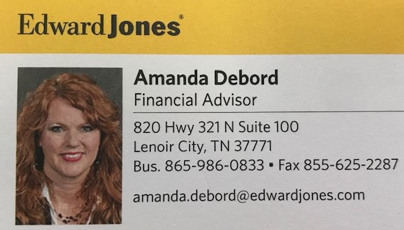

All sandwich boxes prepared by:

Lenoir City and Loudon Co. High School Culinary Arts Classes

Cookies prepared by



**Pick-up/ Delivery Options:**

**_______ Business Delivery 11:30 – 12:30 (ORDERS OF 5 OR MORE BOXES) (11:30 – 12:30)**

**Business Deliver Address: ____________________________________________________________**

**________ Pick up at The Good Samaritan Center**, 119 A Street, Lenoir City **(11:30 – 12:30)**

________ **Pick up at First Baptist Church Tellico Village** (**11:00 a.m.- 1:00 p.m.**).

**Order Deadline:**

**Sept. 4, 2025**

PLEASE CHECK OPTION BELOW

